November 18, 2024

Radovich, Harry (CIB, USA)

J.P. Morgan

383 Madison Avenue, NY, NY

TradeHelm STP POC

Product Scope

Contents

1 Development Components 2

1.1 Webpage 2

1.2 FIX API 2

1.3 Database 2

1.4 STP Certification Workflow 2

2 FX Cash 3

2.1 NDF Sample message 3

2.2 Swap Sample message 3

2.3 Forward Sample message 3

2.4 Spot Sample message 4

2.5 Currency Pairs 4

2.5.1 NDF Currency Pairs 4

2.5.2 G10 Currency Pairs 4

2.5.3 Latam NDF 4

3 FX cash webpage 5

4 Options 6

5 Commodities Product Scope 7

5.1 Precious Metals 7

5.2 Base Metals 7

5.3 Energy 7

5.4 EUA [Outright] 7

5.5 Agriculture 7

# Development Components

## Webpage

The webpage will be used by clients to initiate/simulate trades as if they were using JPM single dealer platform “execute”. This will create a self-service model for post trade API, which eliminates current technical challenges as well as coordination across several teams.

## FIX API

The FIX API will be based on the below product scope. For each distinct product we will want our clients to be able to simulate a trade and receive the corresponding execution report.

## Database

Will maintain the data available for the client to configure and book STP.

## STP Certification Workflow

Figure 1 Current STP Cert Workflow



Figure 2 Future STP Cert Workflow



# FX Cash

## NDF Sample message

8=FIX.4.4|9=666|35=8|34=813|49=JPM-FIX|52=20180205-11:01:54.492|56=CLIENT123 |1= CLIENT-FUND|6=0|14=0|15=USD|17=FPE-9n-2q6o00|31=3.22345|32=12500000.0|37=MORGS_XE-4N4KBO|39=2|54=2|55=USD/BRL|60=20180205-11:01:38.336|64=20180302|75=20180205|119=40293125.0|120=USD|150=F|151=0|155=3.22345|156=M|167=FOR|194=3.2144|195=0.00905|198=E1-312X5H@MORGS_XE-4N4KBO@primary|453=6|448=CLIENT123COP|447=D|452=3|448=WORLDBANK PLC|447=D|452=13|448=ATANKOP|447=D|452=11|448=MORGS|447=D|452=16|448=ECOM|447=D|452=58|448=JPMORGAN|447=D|452=17|762=FXNDF|6203=20180228|10070=PTAX|10601=1030229152GFXATS3M52FDeIQDOBs5Gf1VX82QXXXX|10602=1030229152GFXATS3M52FDeIQDOBs5Gf1VX82QXXXX|10=069|

## Swap Sample message

8=FIX.4.4|9=902|35=8|34=23|49=JPM-FIX-PONI|52=20180606-14:43:07.694|56=NADCFX01|128=ROG_FX_DC|1=TESTDEV3|6=0|14=0|15=USD|17=FPE-AH-C35u04|**22=4**|31=1.34293|32=5000000.0|37=ATS-1H4-MN3Y2W-0-0|39=2|**48=EZ40C36C5194**|54=2|55=GBP/USD|**60=20180606-14:43:04.995884**|64=20180608|75=20180606|119=3723202.25|120=GBP|150=F|151=0|155=1.34293|156=D|167=FOR|192=5000000.0|193=20180615|194=1.34293|195=0.0|198=EHP-26R56F@ATS-1H4-MN3Y2W-0-0@primary|453=7|448=HAVIGL|447=D|452=3|448=D554560|447=D|452=11|448=MORGS|447=D|452=16|448=ECOM|447=D|452=58|448=JPMORGAN|447=D|452=17|**448=7H6GLXDRUGQFU57RNE97|447=N|452=1**|**448=N|447=D|452=63**|**448=JP|447=P|452=73|528=P**|640=1.343281|641=0.000351|762=FXSWAP|7596=3722229.38|7597=0.000351|10601=1030229152GFXFXA0000000000000000I7Z1VXFL4U|10602=1030229152GFXFXA0000000000000000I7Z1VXFL4U|**10603=1030229152GFXFXA0000000000000000I7Z1VXFL4V|10604=1030229152GFXFXA0000000000000000I7Z1VXFL4V**|**12668=2|12669=0|12670=4|12669=1|12670=7|**10=254|

## Forward Sample message

8=FIX.4.4|9=607|35=8|34=981|49=JPM-FIX|52=20180205-14:00:16.763|56=NADCFX01|1= CLIENT123Account|6=0|14=0|15=EUR|17=FPE-AH-Adkr0J|31=1.251372|32=5000.0|37=ATS-21O-B2ZQ31-0-0|39=2|54=1|55=EUR/USD|60=20180205-14:00:14.313|64=20180507 |75=20180205|119=6256.86|120=USD|150=F| 151=0|155=1.251372|156=M|167=FOR|194=1.2439|195=0.007472|198=EHP-1RKDQK@ATS-21O-B2ZQ31-0-0@primary|453=5|448=CLIENTGLOB|447=D|452=3|448=ROMAIN-T |447=D|452=11|448=MDRFQ|447=D| 452=16|448=ECOM|447=D|452=58|448=JPMORGAN|447=D|452=17|762=FXFORWARD|10601=1030229152GFXFXA0000000000000000I7Z1O5BG3A|10602=1030229152GFXFXA0000000000000000I7Z1O5BG3A|10=191|

## Spot Sample message

8=FIX.4.4|9=672|35=8|34=10|49=JPM-FIX-PONI|52=20180606-14:31:44.613|56=NADCFX01 |1=TESTDEV3|6=0|14=0|15=EUR|17=FPE-AH-C35r02|**22=4**|31=1.17776|32=1000000.0|37=ATS-1H4-MN3ARI-0-0|39=2|**48=EZB1C6503CB2**|54=2|55=EUR/USD|**60=20180606-14:31:42.923395**|64=20180608|75=20180606|119=1177760.0|120=USD|150=F|151=0|155=1.17776|156=M|167=FOR|194=1.17776|198=EHP-26R42Z@ATS-1H4-MN3ARI-0-0@primary|453=7|448=HAVIGL|447=D|452=3|448=D554560|447=D|452=11|448=MORGS|447=D|452=16|448=ECOM|447=D|452=58|448=JPMORGAN|447=D|452=17|**448=7H6GLXDRUGQFU57RNE97|447=N|452=1**|**448=N|447=D|452=63**|**448=JP|447=P|452=73**||**528=P**|762=FXSPOT|10601=1030229152GFXFXA0000000000000000I7Z1VXGP48|10602=1030229152GFXFXA0000000000000000I7Z1VXGP48|10=019|

## Currency Pairs

### NDF Currency Pairs

JPY-IDR, KRW-GBP, TWD-NOK, PHP-NOK, IDR-SEK, IDR-USD, INR-USD, IDR-SGF, INR-GBP, PHP-AUD, KRW-EUR, KRW-USD, TWD-HKD, PHP-GBP, IDR-CAD, INR-SEK, PHP-SGD,   
IDR-CHF, PHP-SGF, IDR-NZD, INR-EUR, INR-SGF, JPY-PHP, KRW-NZD, TWD-SGF, TWD-USD, PHP-SEK, PHP-HKD, TWD-EUR, TWD-CHF, KRW-SGF, INR-SGD, TWD-NZD, KRW-HKD, KRW-NOK, PHP-DKK, IDR-SGD, KRW-AUD, INR-CAD, INR-NZD, INR-AUD, TWD-AUD  
PHP-USD, IDR-DKK, INR-CHF, IDR-NOK, KRW-CAD, TWD-SGD, INR-DKK, IDR-GBP, KRW-JPY, INR-NOK, INR-JPY, PHP-CAD, TWD-GBP, PHP-NZD, PHP-CHF, KRW-SGD, IDR-EUR, INR-HKD, KRW-CHF, TWD-SEK, IDR-AUD, TWD-DKK, TWD-CAD, TWD-JPY, IDR-HKD,  
KRW-DKK, PHP-EUR, KRW-SEK

### G10 Currency Pairs

SEK-USD, USD-NZD, CHF-USD, USD-AUD, NOK-USD, DKK-USD, CAD-USD, JPY-USD, USD-GBP, USD-EUR

### Latam NDF

GTQ-USD, BRL-USD, VEB-USD, ARS-USD, UYU-USD, PEN-USD, CLP-USD, COP-USD

# FX cash webpage

The webpage allows clients to self-certify the STP workflow. The client will require the ability to input certain product and trade parameters in order to initiate and verify a variety of different STP messages.

Client should be able to Input the following trade parameters for STP.

* **Product:** FX Cash, FX Options, Commodities (Agriculture, Energy, Basemetals, Indices) (167) SecurityType
* **Security:** Forward, NDF, Swap, Spot. Drop down this feeds tag (762) SecuritySubType
* **Currency pair:** Available values in Currency Pairs section. This will feed tag (55) Symbol
* **Settle Date (Value Date):** Provide a date picker. User can select from any dates including todays date and beyond. This will feed tag (64) SettlDate.
* **Notional:** User defined input. This will feed tag (32) LastQty.
* **Side:** Buy or Sell (54) Side
* **Book:** This will generate the STP message and should only become selectable when all other required attributes are populated

Note: For swaps we may need another value date for the other leg or we can infer it based on the one clients select. Same for fixing date, which will determine the date when the FX rate is set. For fixing date we can always make it a couple days prior to the value date.

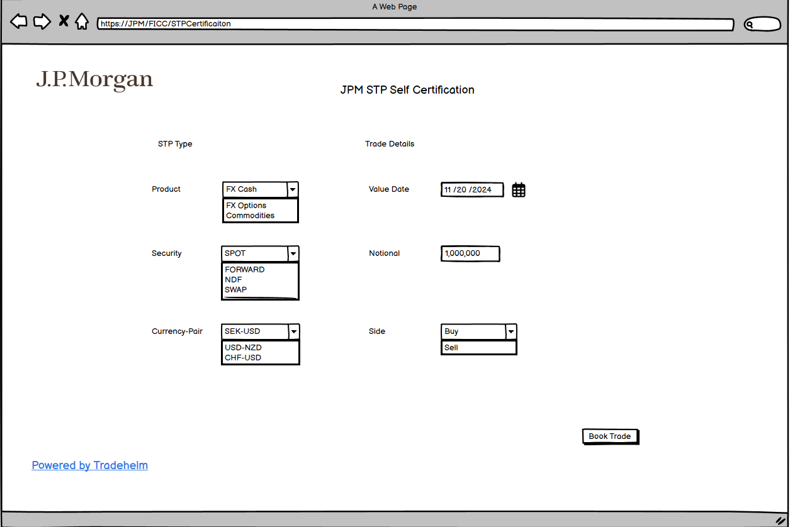

# Options

# Commodities Product Scope

## Precious Metals

## Base Metals

## Energy

## EUA [Outright]

## Agriculture